1. Open the URL - http://192.168.23.239:9000/
2. Download Expenses-Tracker-WebApp to your local PC
OR Git clone : https://github.com/mohamed0sawy/Expenses-Tracker-WebApp.git
3. On VScode open the file src/main/resources/application.properties
4. Change the MySQL username/password to your PC's MySQL username/password
5. Open Command Prompt and ensure Java is installed using the command "java -version"
6. Download and install Apache Maven from this URL: https://medium.com/@gauravshah97/how-to-install-maven-on-windows-39ff317e40cf
7. Create a database called "expenses_tracker" in your MySQL
8. Go to your projects directory and Run the command "mvn clean install"
9. Run the command "java -jar target/expenses-tracker.jar" (jar file name could be different on your device so check the target directory before running the command)
10. Open http://localhost:8080 to see the app deployed
11. Install Filezilla on Windows if its not installed yet
12. Start Ubuntu on virtualbox
13. Stop your windows java application by Crtl+C
14. Move the project folder from the Windows to Ubuntu using FileZilla
15. On Windows find your IP address for the windows machine using ipconfig ("ip addr" for ubuntu) command. It should be "192.168.xxx.xxx"
16. Open the application.properties file again and replace the DB hostname from the localhost to this ipaddress from step 15
17. Rebuild the application from Windows using the command "mvn clean install"
18. See if the application is still accessible from localhost:8080
19. Install openssh-server on Ubuntu with the command "sudo apt install openssh-server"
Ubuntu IP address command "ip addr"
20. Install Java on Ubuntu using the command "sudo apt install openjdk-21-jdk"
21. Now from the folder where your jar file is copied on Ubuntu, run the command "java -jar filename.jar (check target directory for filename)
22. On Ubuntu, install MySQL by "sudo apt install mysql-server" (try running "sudo apt update" if this command doesn't work), Then start MySQL using the command "sudo mysql -u root", write 'exit;' to exit
23. Create a new MySQL user using the following commands
CREATE USER 'admin'@'%' IDENTIFIED BY 'admin';
GRANT ALL PRIVILEGES ON *.* TO 'admin'@'%' WITH GRANT OPTION;
FLUSH PRIVILESGES;
24. Run "sudo mysql -u root" and create a database called "expenses_tracker" using command CREATE DATABASE expenses_tracker;
25. Go to the folder where you have copied the application
26. Run the command "sudo apt install maven"
27. run mvn --version
28. run mvn clean install
29. Change username/password in application.properties file to 'admin'
30. java -jar target/filename.jar
Now go to windows, open the chrome browser, put this in the search bar:
Ubuntu_IP_address:8080 (check the IP address for ubuntu using "ip addr"
If you see the application running, then everything works!
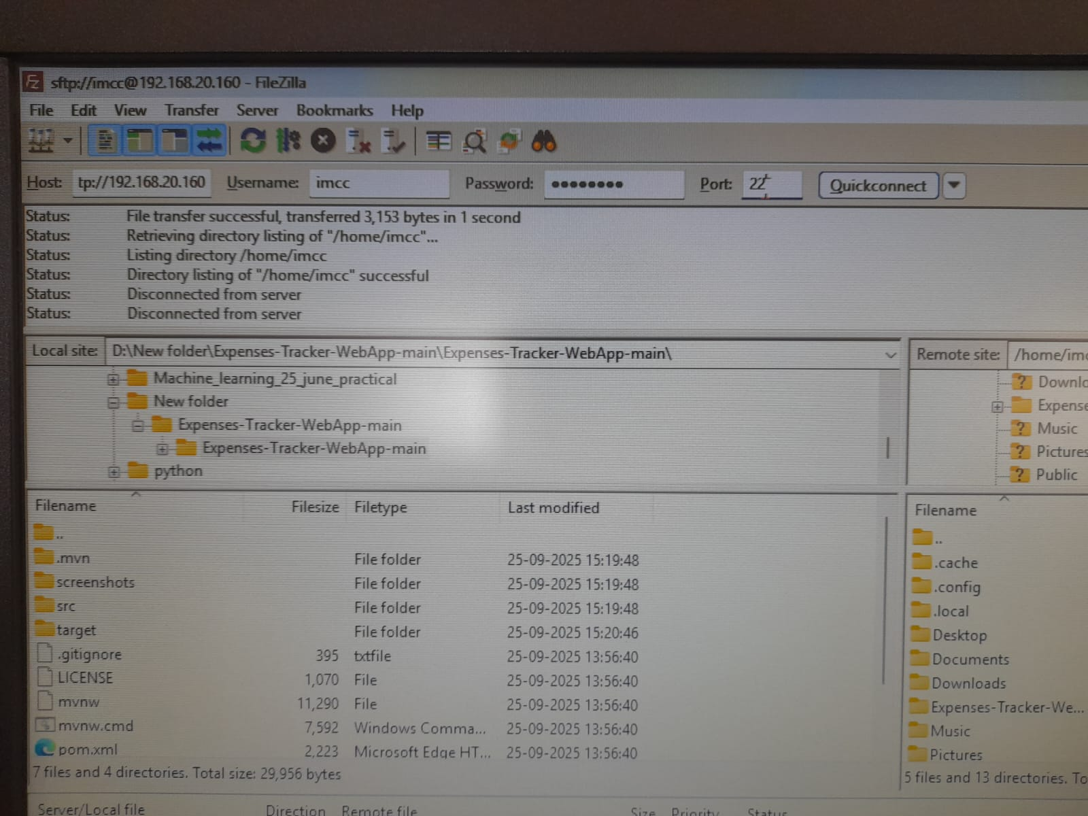
This is the filezilla interface, on the left locate your application directory, select it
In host section put IP address of ubuntu, username = imcc, pass = imcc@123, port = 22 and hit ‘Quick Connect’
Select your application directory, right-click and hit upload
This should Transfer the files from windows to ubuntu


Cheer mate!
Put together by @4rnavc

